MEMBERSHIP APPLICATION FORM for NRHS and CAPE COD CHAPTER 2020
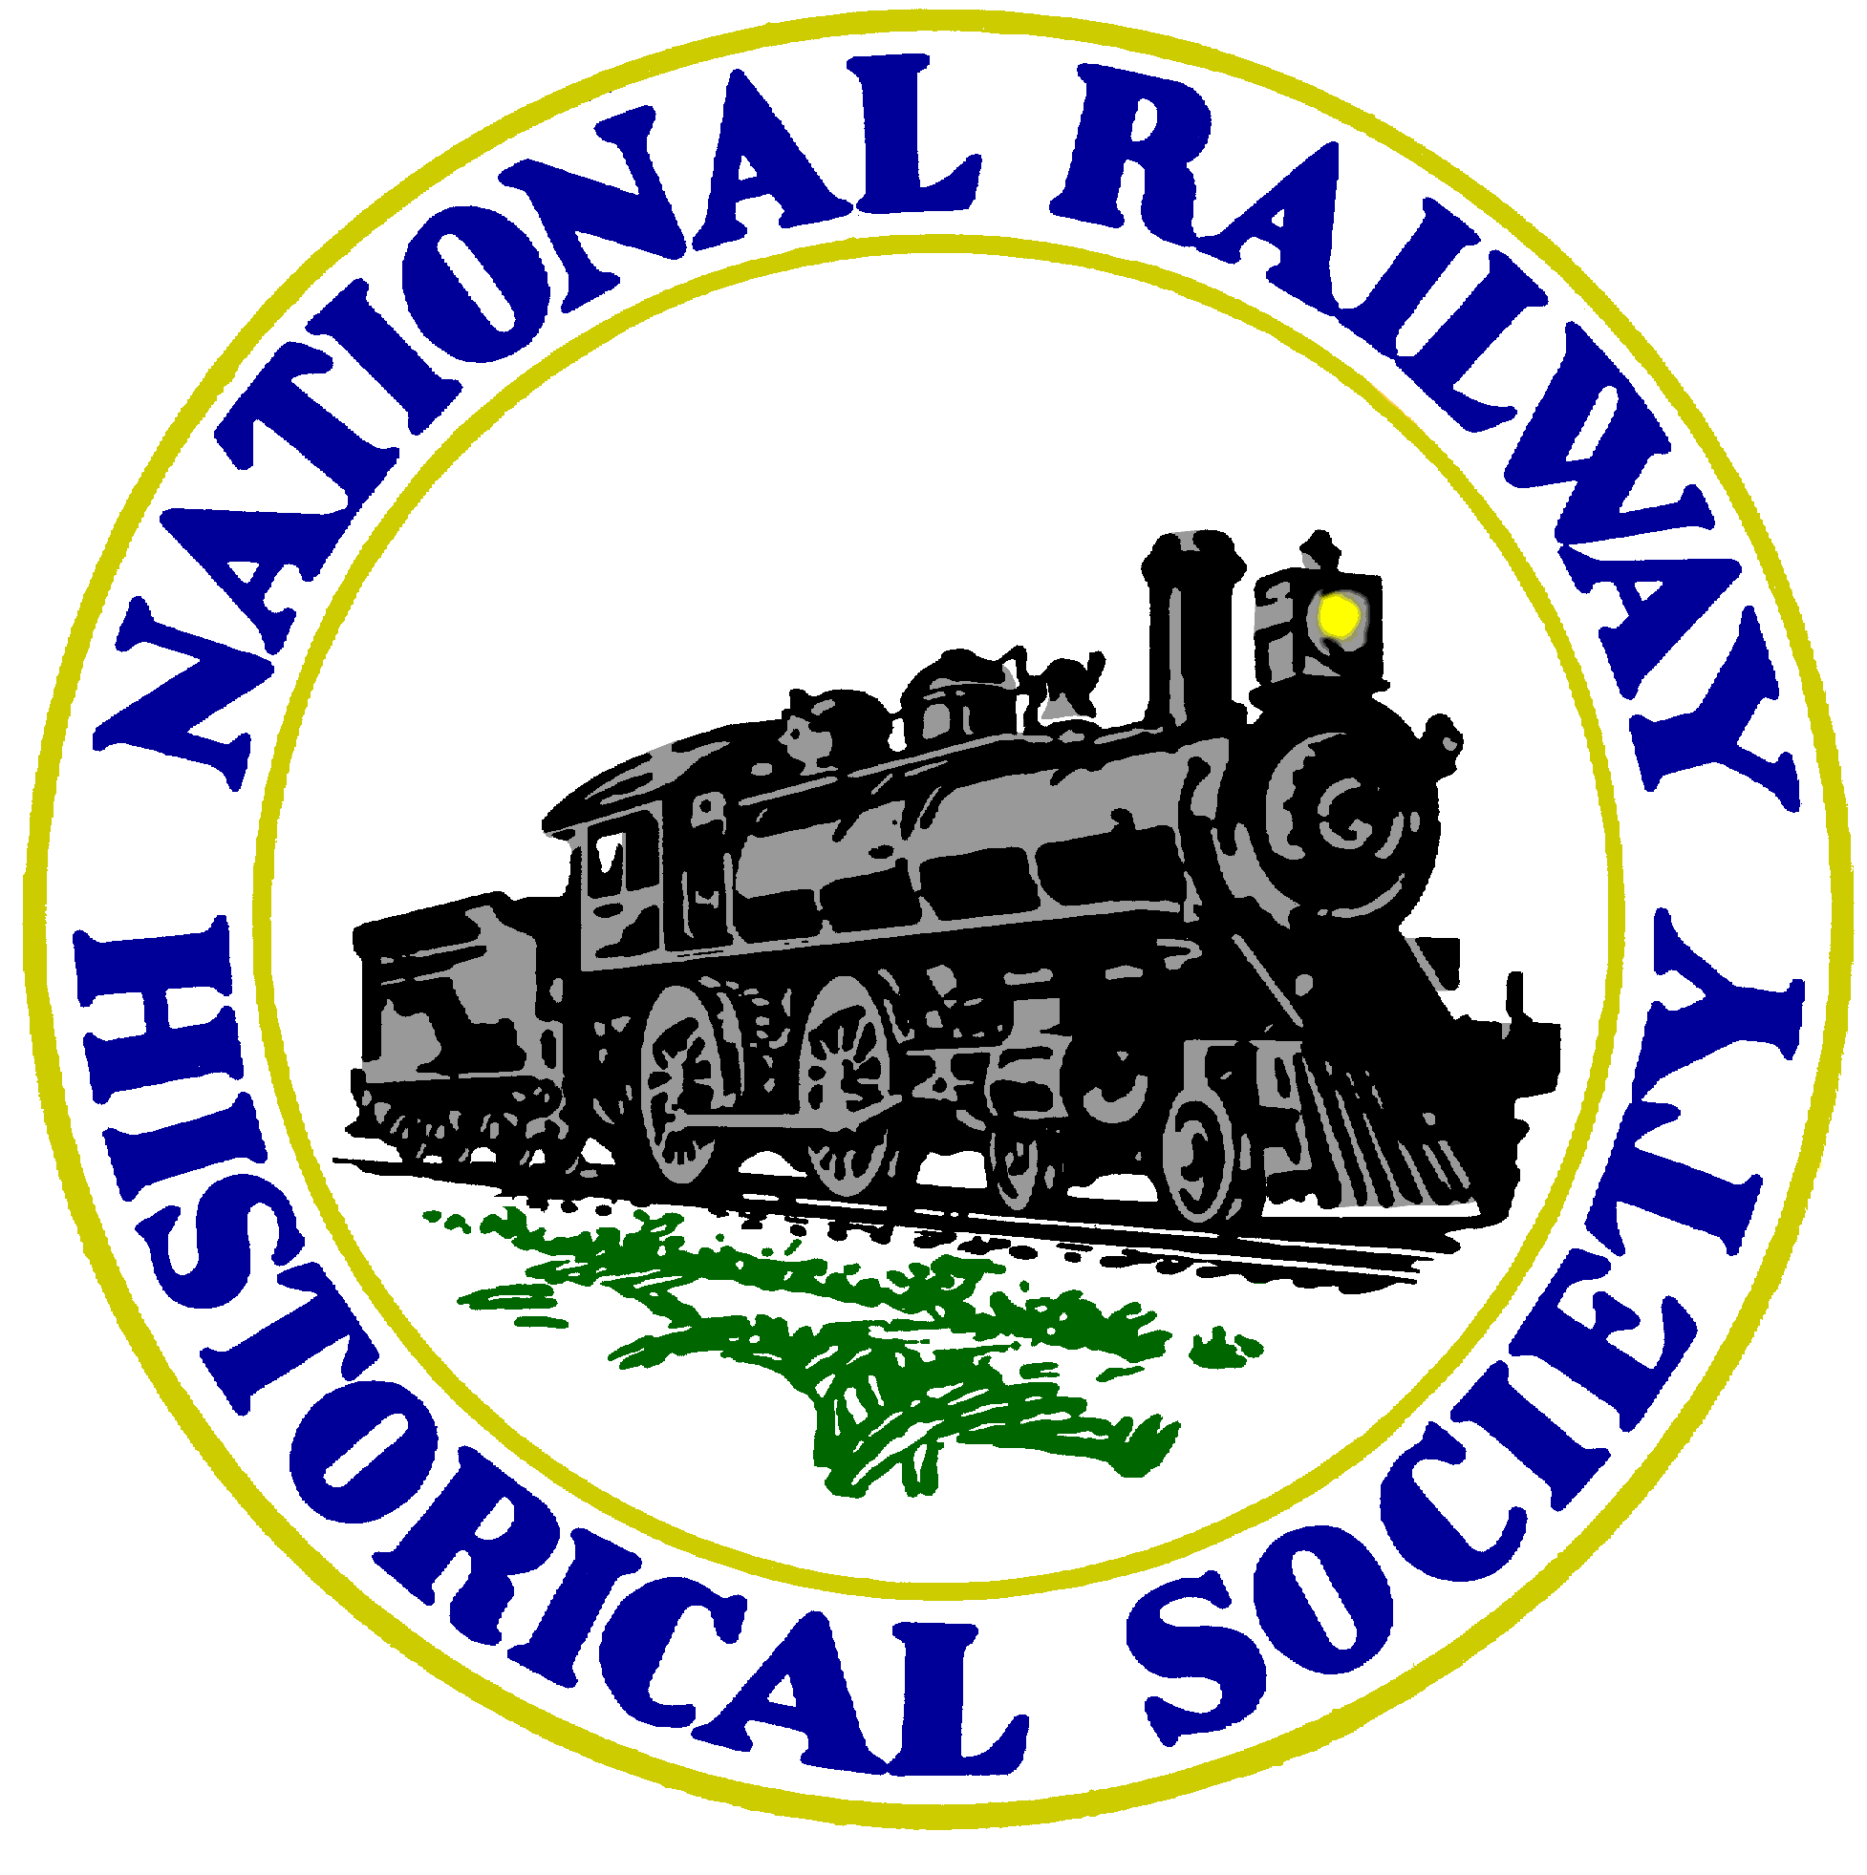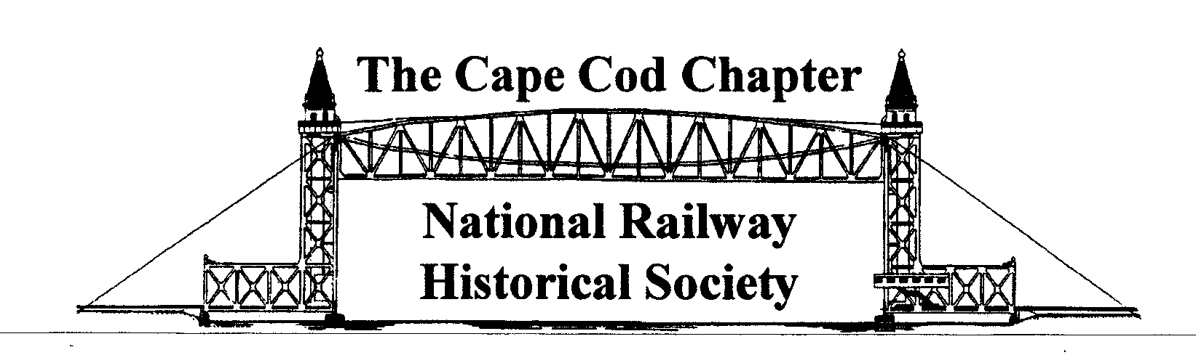
PRINT CLEARLY

Name
Address
City State Zip + 4
Home Phone Number Cell Phone Number
Email Address

If you have been a NRHS member before, please fill in your Membership Number: __________________

Additional Family Member Names
Occupation or Special Talents
□ I would like to Volunteer (Help out at West Barnstable Train Station, sell train ride tickets Saturdays, help with the building maintenance/restoration, assist with our events, organize displays and artifacts, PR publicity.)

Memberships Includes National and Chapter:
Regular Individual Dues (National and Chapter) ($50/$11) $61.00 ____________
Additional Family Member(s) ($7/$7) (May include a Student or Youth) $14.00
Student - Ages 13 to 24 ($16/$11) $27.00
Youth - Ages 5 to 12 (Parent or guardian’s signature is required) ($5/$11) $16.00
Total Membership Fees:

I agree to abide by the Constitution and By-Laws of the Cape Cod Chapter, NRHS and the Rules and Regulations of the West Barnstable Train Station & Museum and NRHS as applicable.

Signature Date

Check payable to: Cape Cod Chapter, NRHS.

Send this form and payment to our Membership Chairman:

Mr. Douglas Scott, Membership Chair, 250 Mary Chase Road, Eastham, MA 02642

Thank you for your application – it is subject to approval by the Chapter.
2469 Meetinghouse Way, Route 149, West Barnstable, MA 02668
Website: www.capecodnrhs.org and Facebook

Benefits of Membership in the NRHS
Benefits of NRHS Membership include:
- Issues of the NRHS Bulletin as published each year
- 6 issues of the NRHS News
- Membership Card
- Discounts to various rail attractions around the country
- Advanced ticket purchase to the NRHS Convention
- An, organized, safe, international network of railroading; an excellent opportunity to meet and
socialize with other people who have similar interests in railroads, rail preservation, photography, writing, operations, restoration, and/or history and many programs, including Operation Lifesaver, Rail Camp and Research.
- Opportunities to contribute time and energy to local projects or national efforts that protect, educate, preserve, and promote the past, and present, and future of railroading.

Further, all Chapter Members and Friends of the West Barnstable Train Station may participate in Chapter events and projects and electronically receive The Cape Rail Dispatch, our monthly newsletter publication.
Membership Requirements: All members of the National Railway Historical Society are required to maintain their membership in good standing by paying their annual dues and to abide by the Bylaws of the organization, local and national. See www.nrhs.com. If you would like a copy of the Constitution and By-Laws, please contact the National Office and see the bylaws page. You must be a member of NRHS to be a Chapter member.

Cape Cod Chapter Annual Membership Dues

National Society Individual Dues is billed separately for $50.00. Chapter dues are $11.00 per year. Spouses may also join for an additional $7.00 each per year. Student memberships are $11.00 to the Chapter and $16.00 to National billed separately. Youth Chapter memberships are just $5.00 per year and National Dues are $5.00 billed separately. Parent or legal guardian signature is required just in this Youth category.
Memberships run from January 1 - December 31st. New members joining after September 1 receive membership for the current year plus all the next following year at the regular price. Memberships not renewed by January 31 are cancelled and will be submitted as a new member after that deadline.

Family Friendly Membership

For a nominal additional fee, the other members of your family can become NRHS Members too. Family members receive full rights and privileges of NRHS Membership participation, such as discounts, convention participation, a membership card and the chance to belonging to and socialize with a really fun group of people. A family member is defined simply as an individual living in the same household.

Student & Youth Membership

A student or youth membership is a discounted annual membership offered to individuals who are under 25 years of age (on January 1). The purpose of the student and youth categories are to introduce the NRHS to the many young people who have an interest in one or more aspects of railroading. As a student or youth member, you will receive the NRHS Bulletin and the NRHS News.

